Name: Sanee Salim

Student ID:101887181

Unit Code: COS20019

Unit Title: Cloud Computing Architecture

Assignment 2 Report

# VPC Subnets

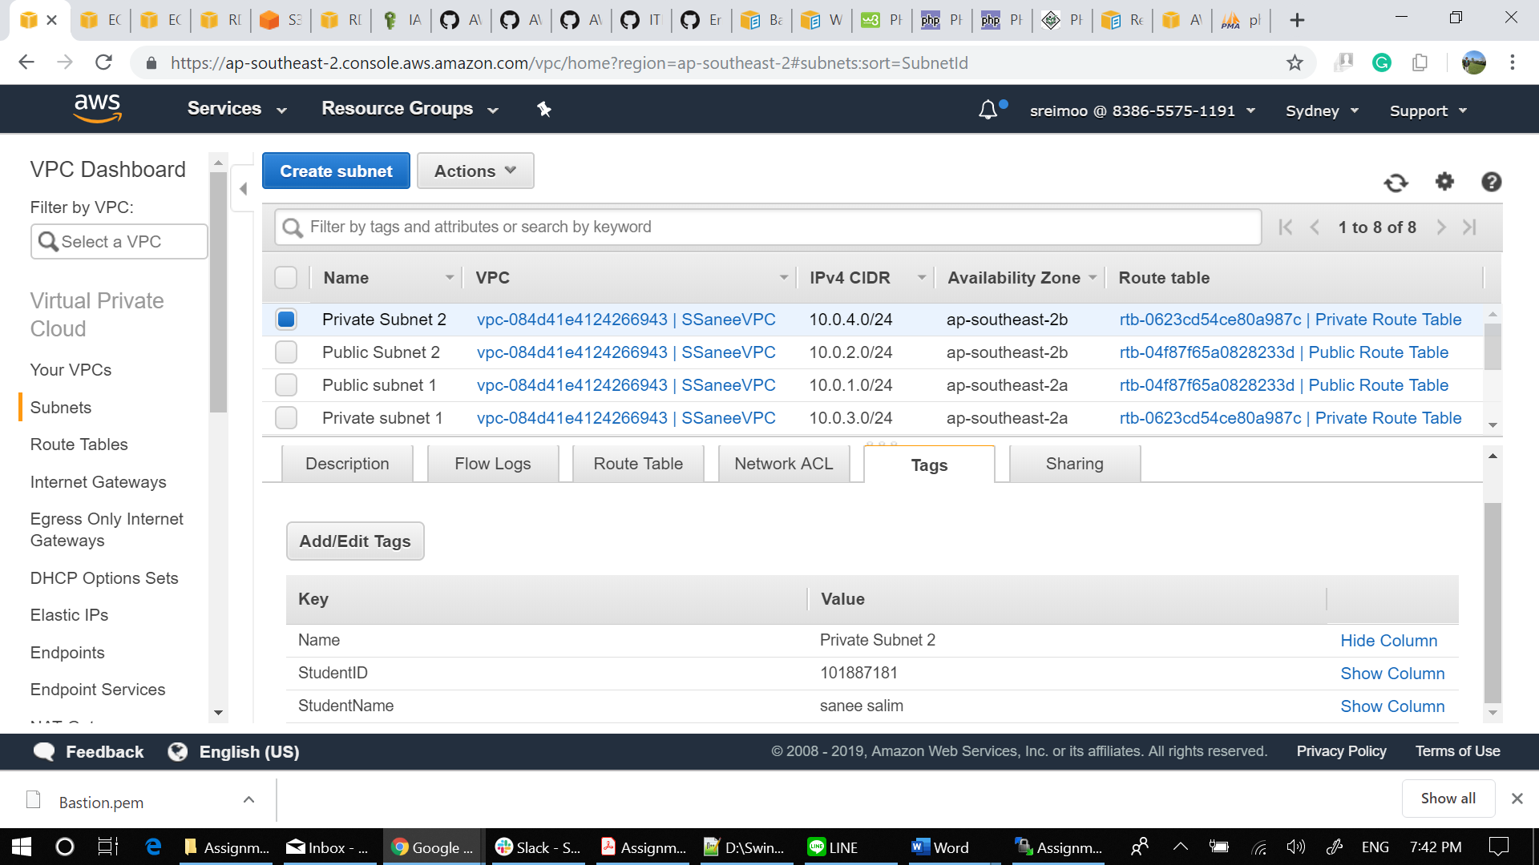

## VPC Route Table

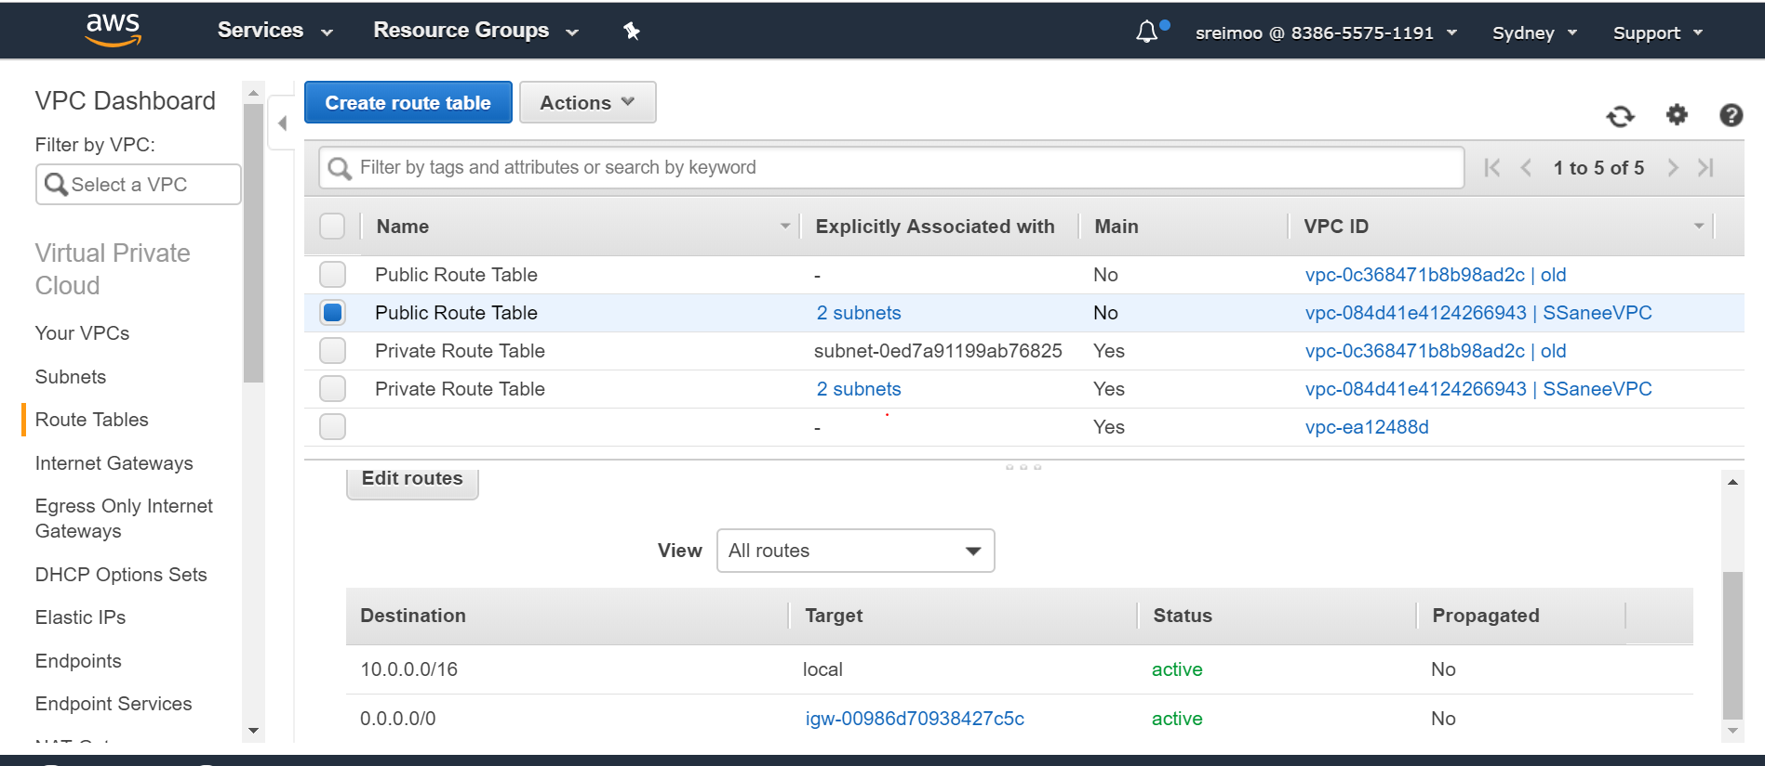

# Web Tier Security Group

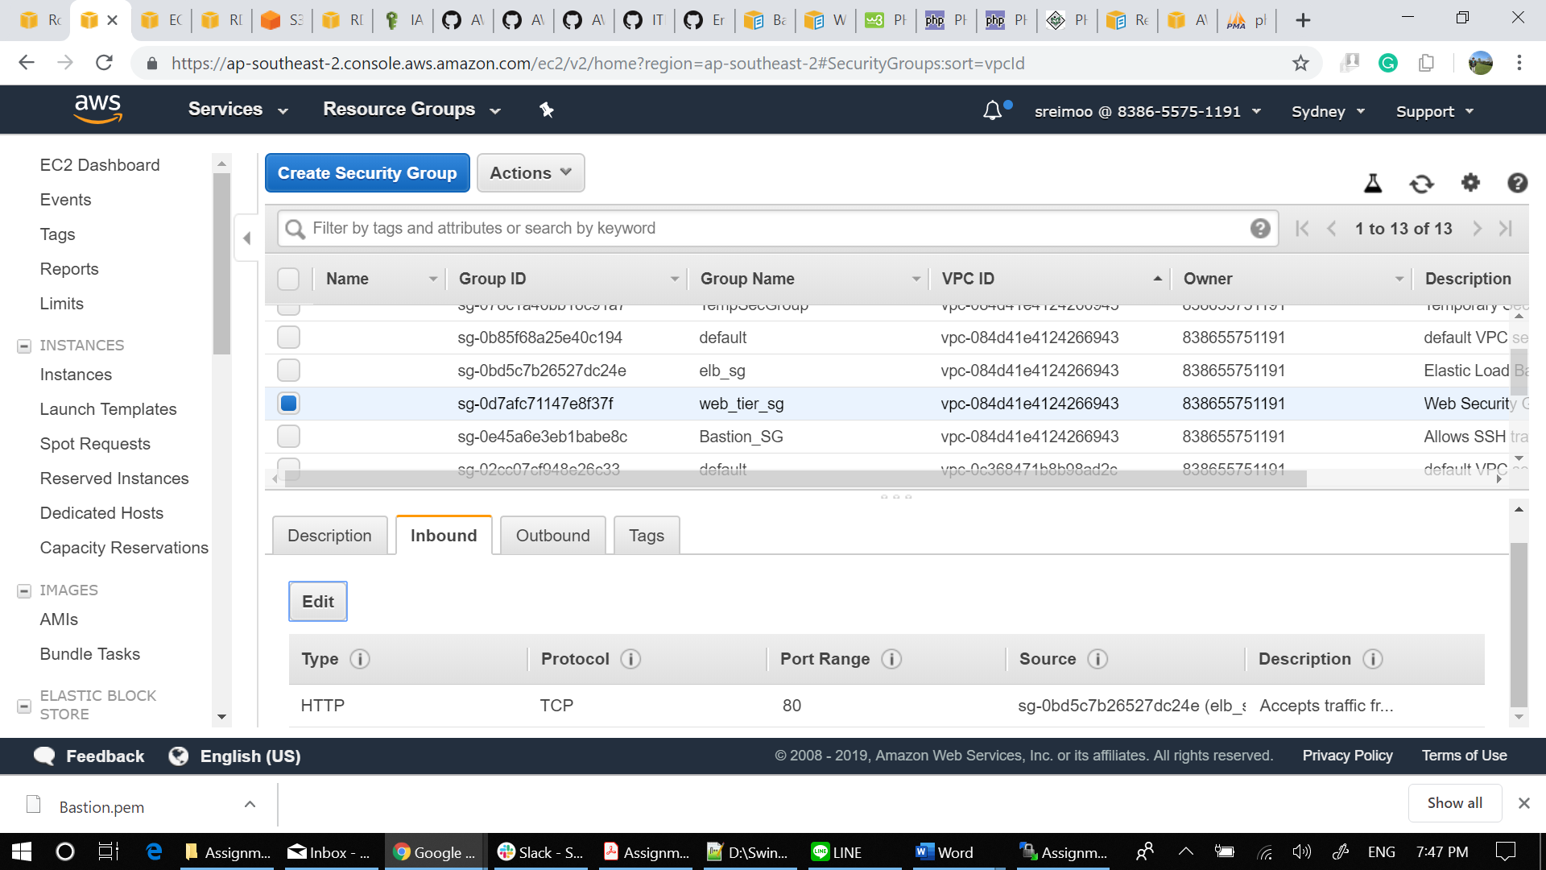

## ELB Security Group

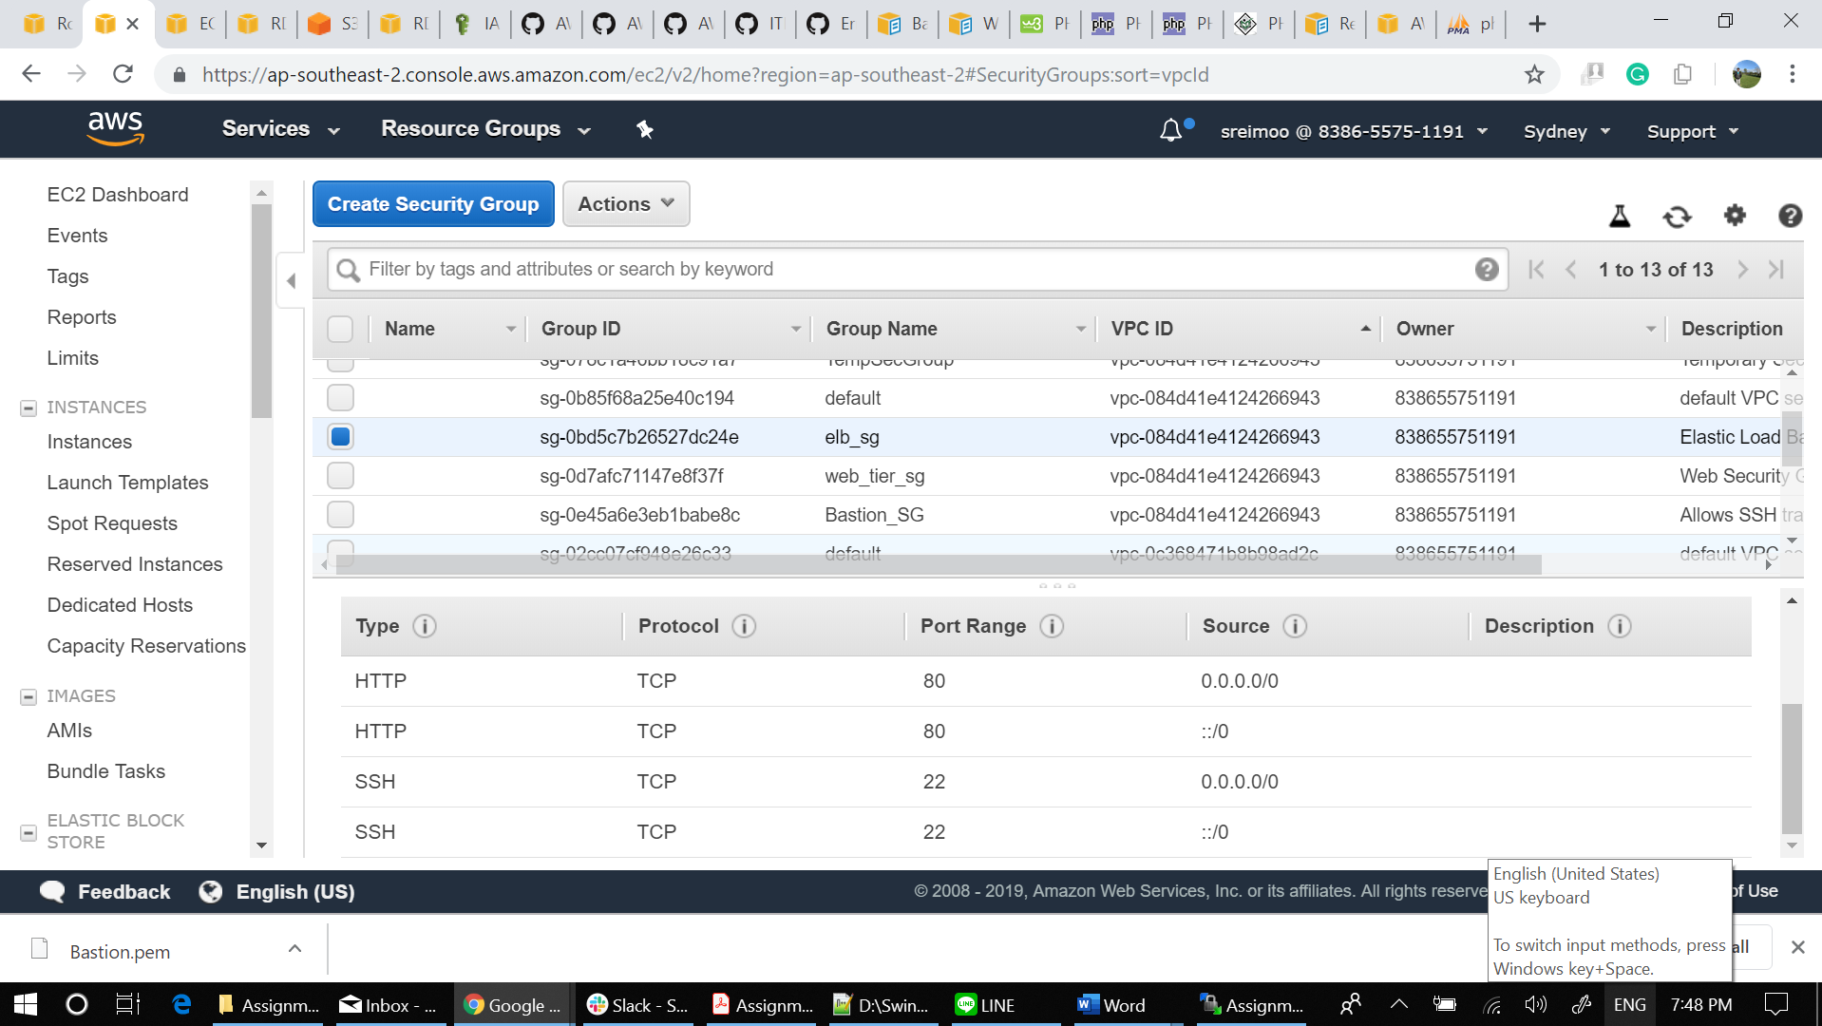

## DB Security Group

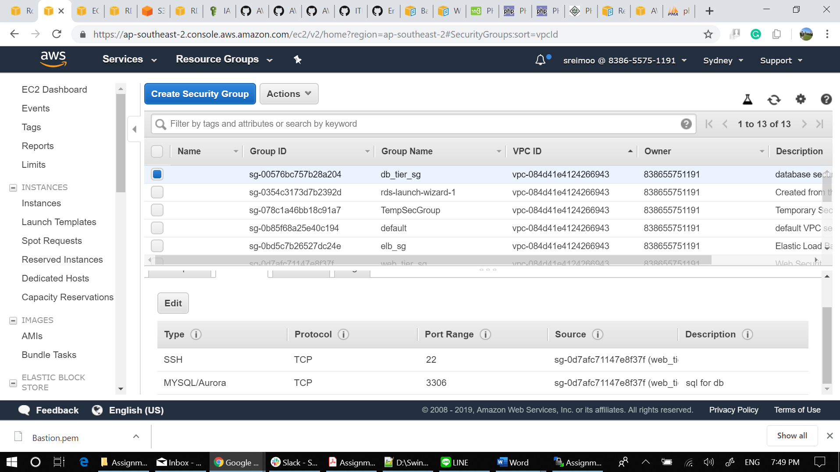

# Running EC2 Instances

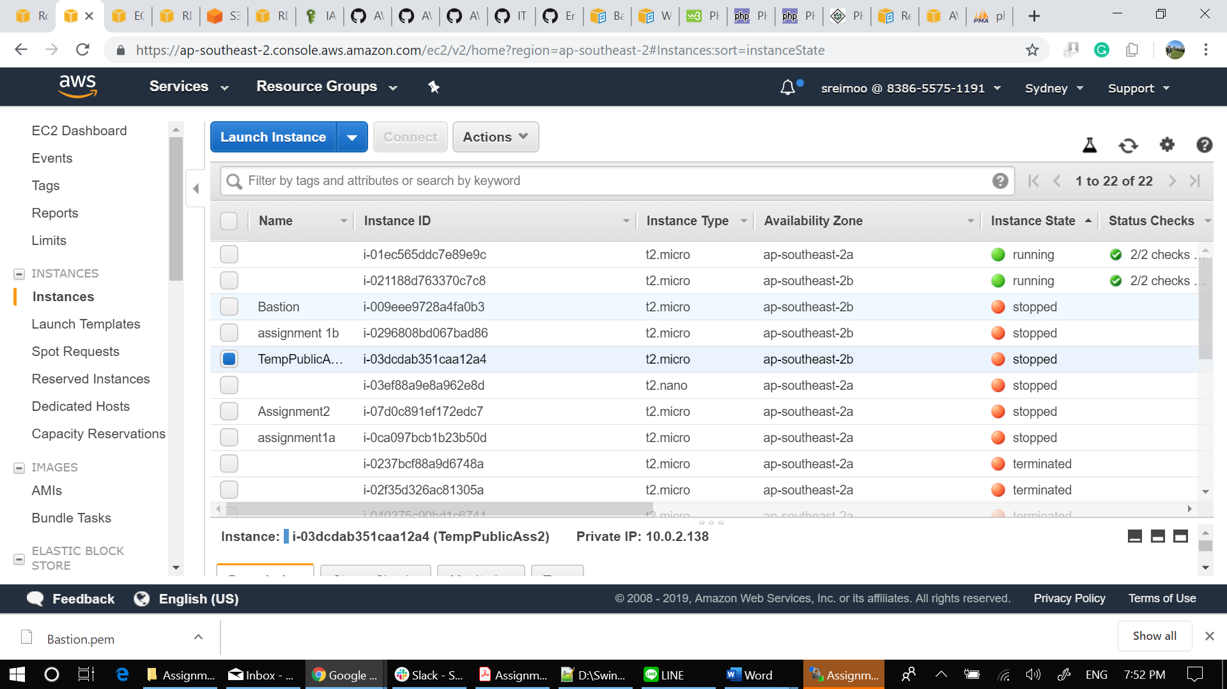

## Instance 1 tags

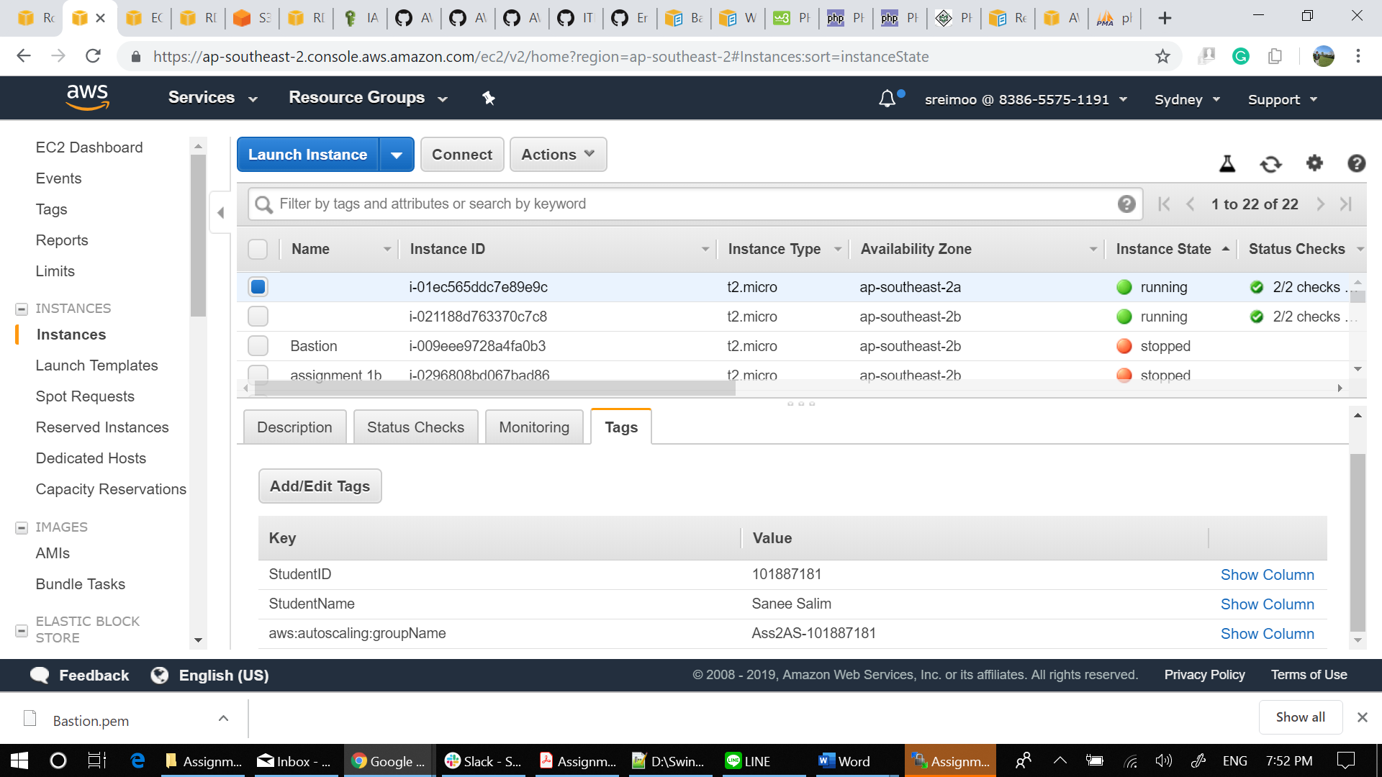

## Instance 2 tags

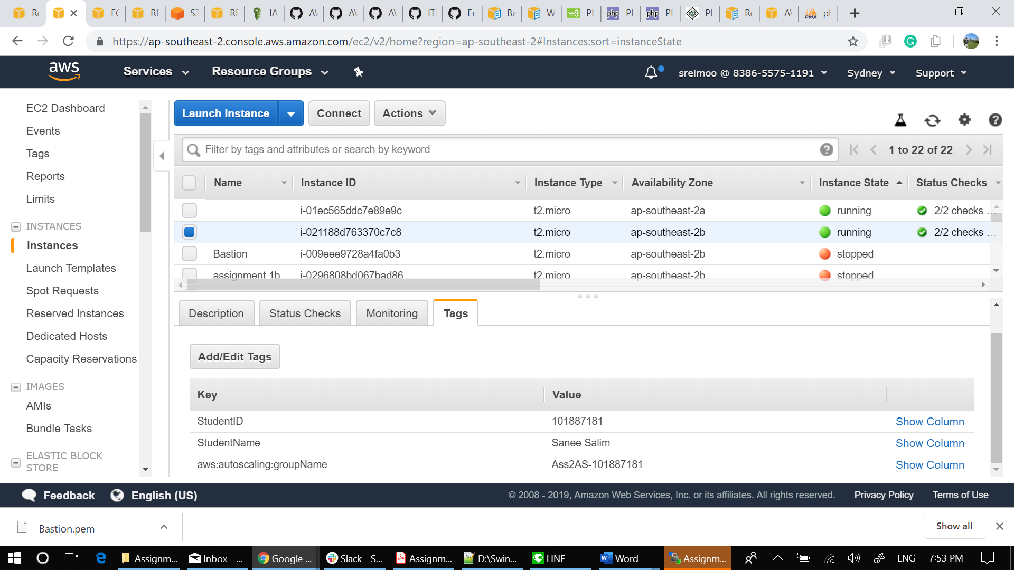

## Instance 1 Description

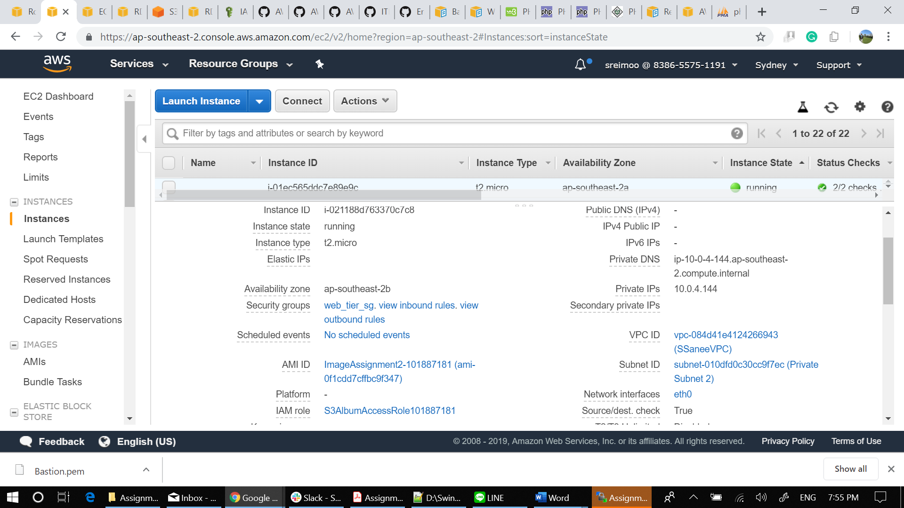

## Instance 2 Description

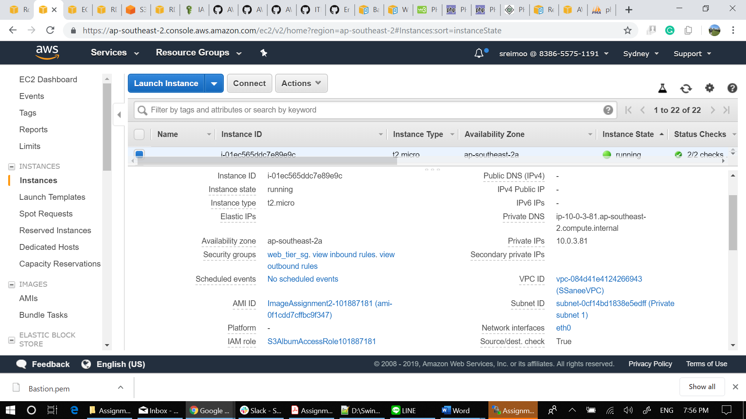

# RDS Instance Page

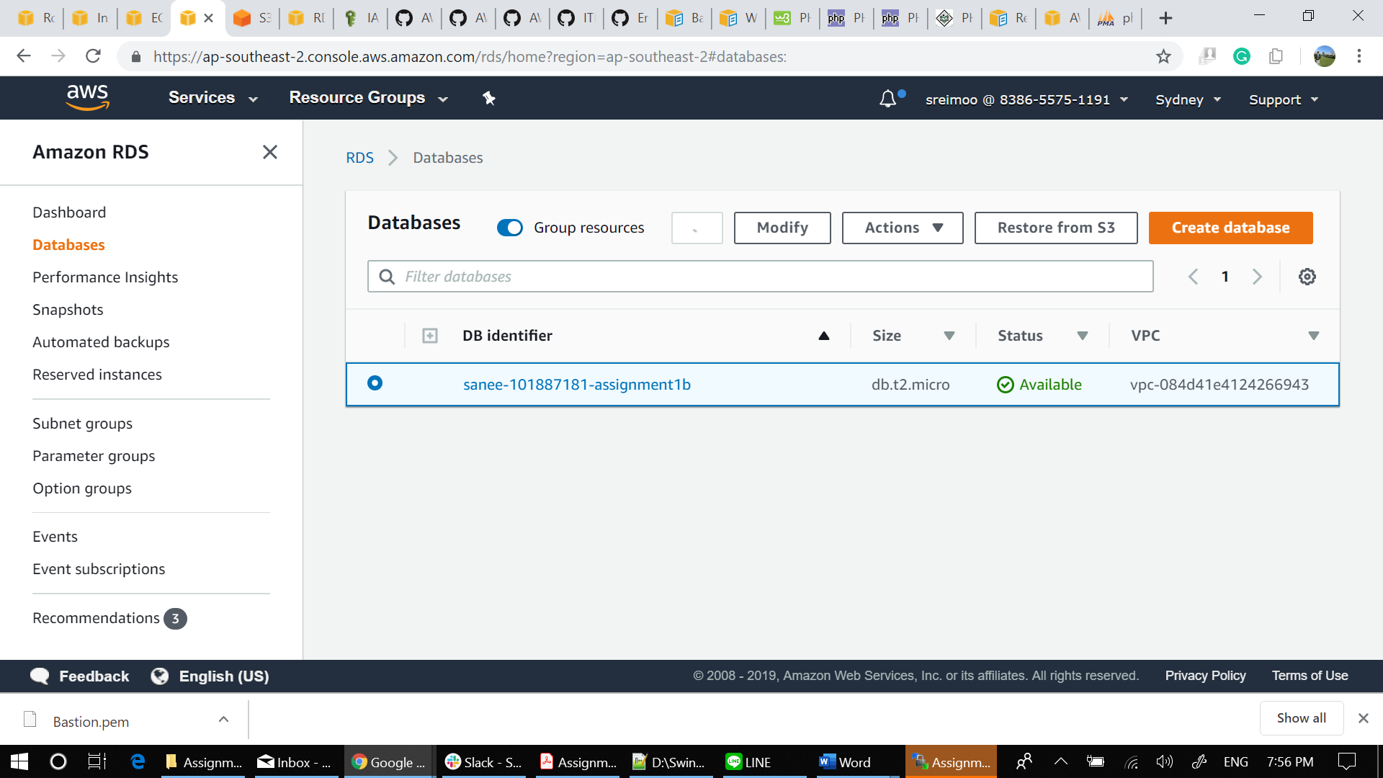

***NOTE FOR THE CHECKER:***

***AS CAN BE SEEN IN THE SCREENSHOTS BELOW THAT I HAVE A LOAD BALANCER CONFIGURED BUT MY CLOUDFORMER DID NOT READ IT FOR UNKNOWN REASONS WHICH IS WHY IT IS MISSING IN CLOUDFORMER***

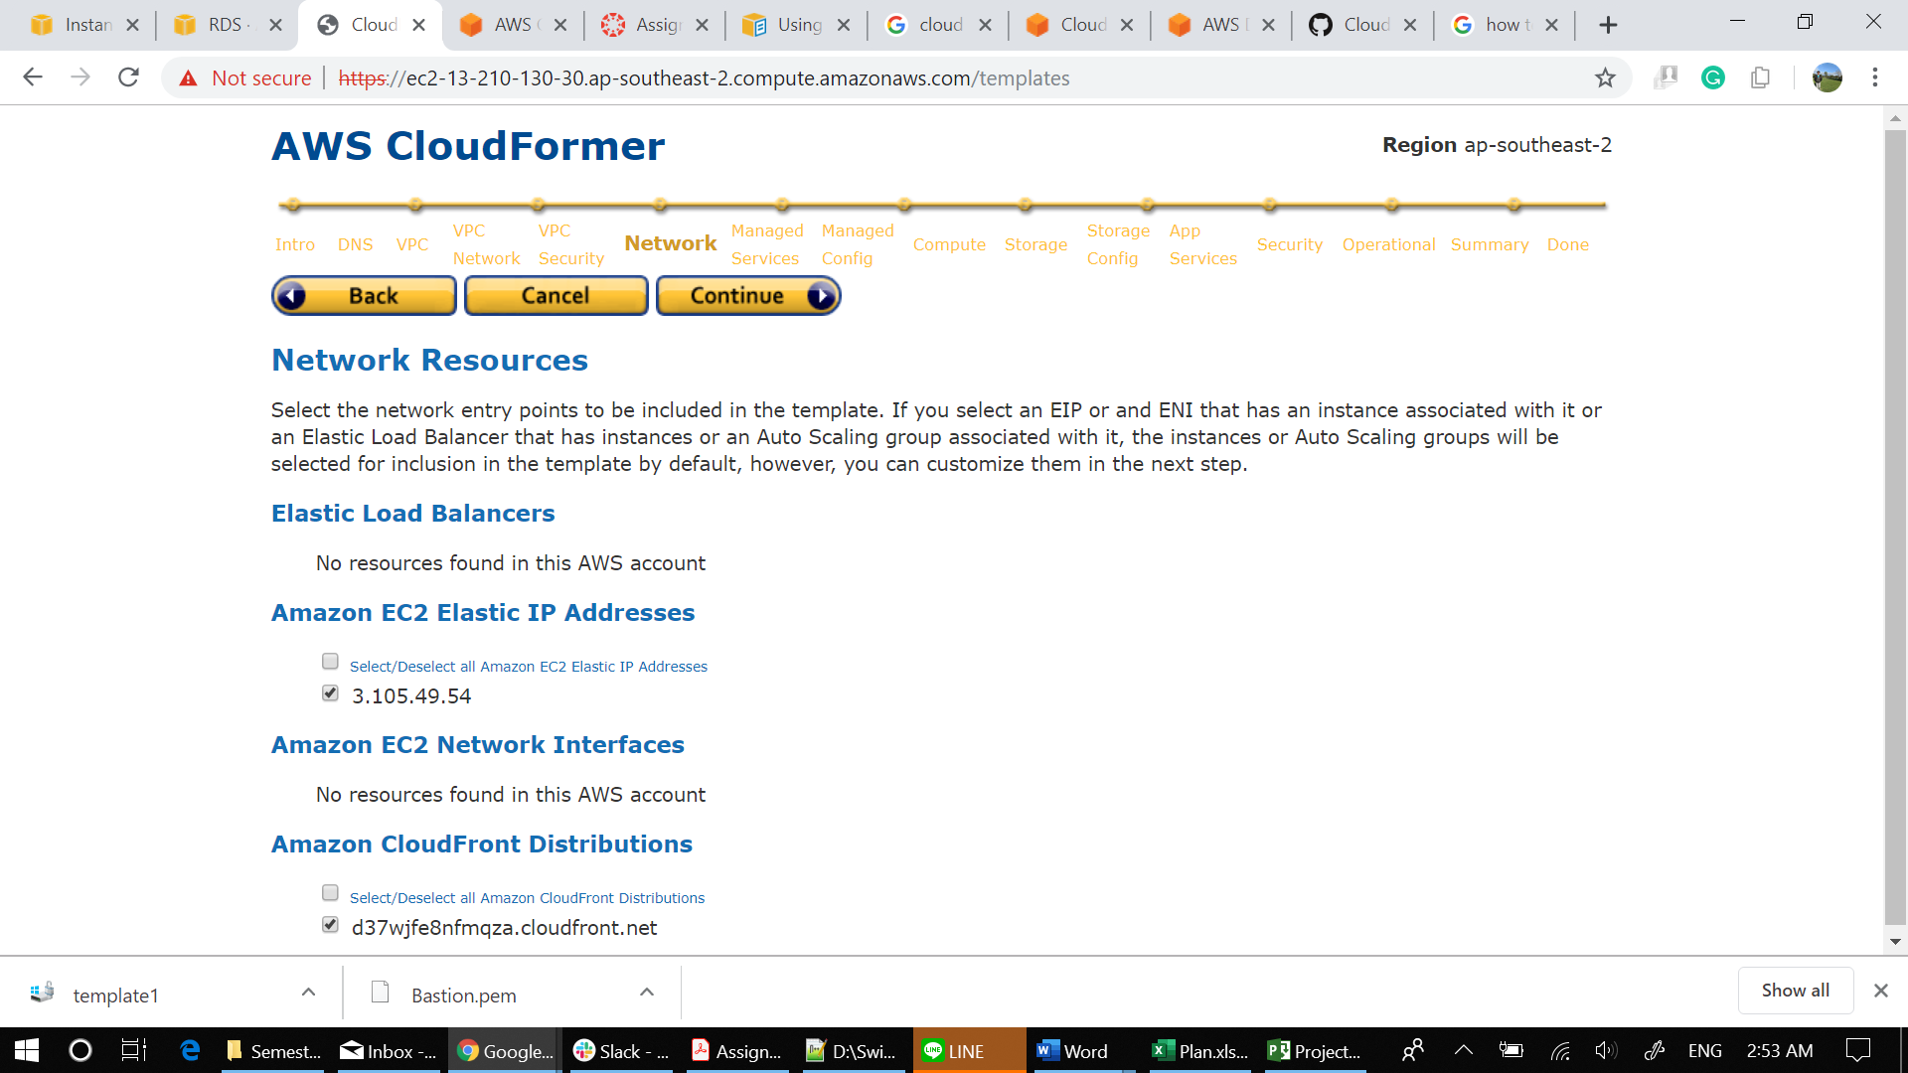

# Lb1

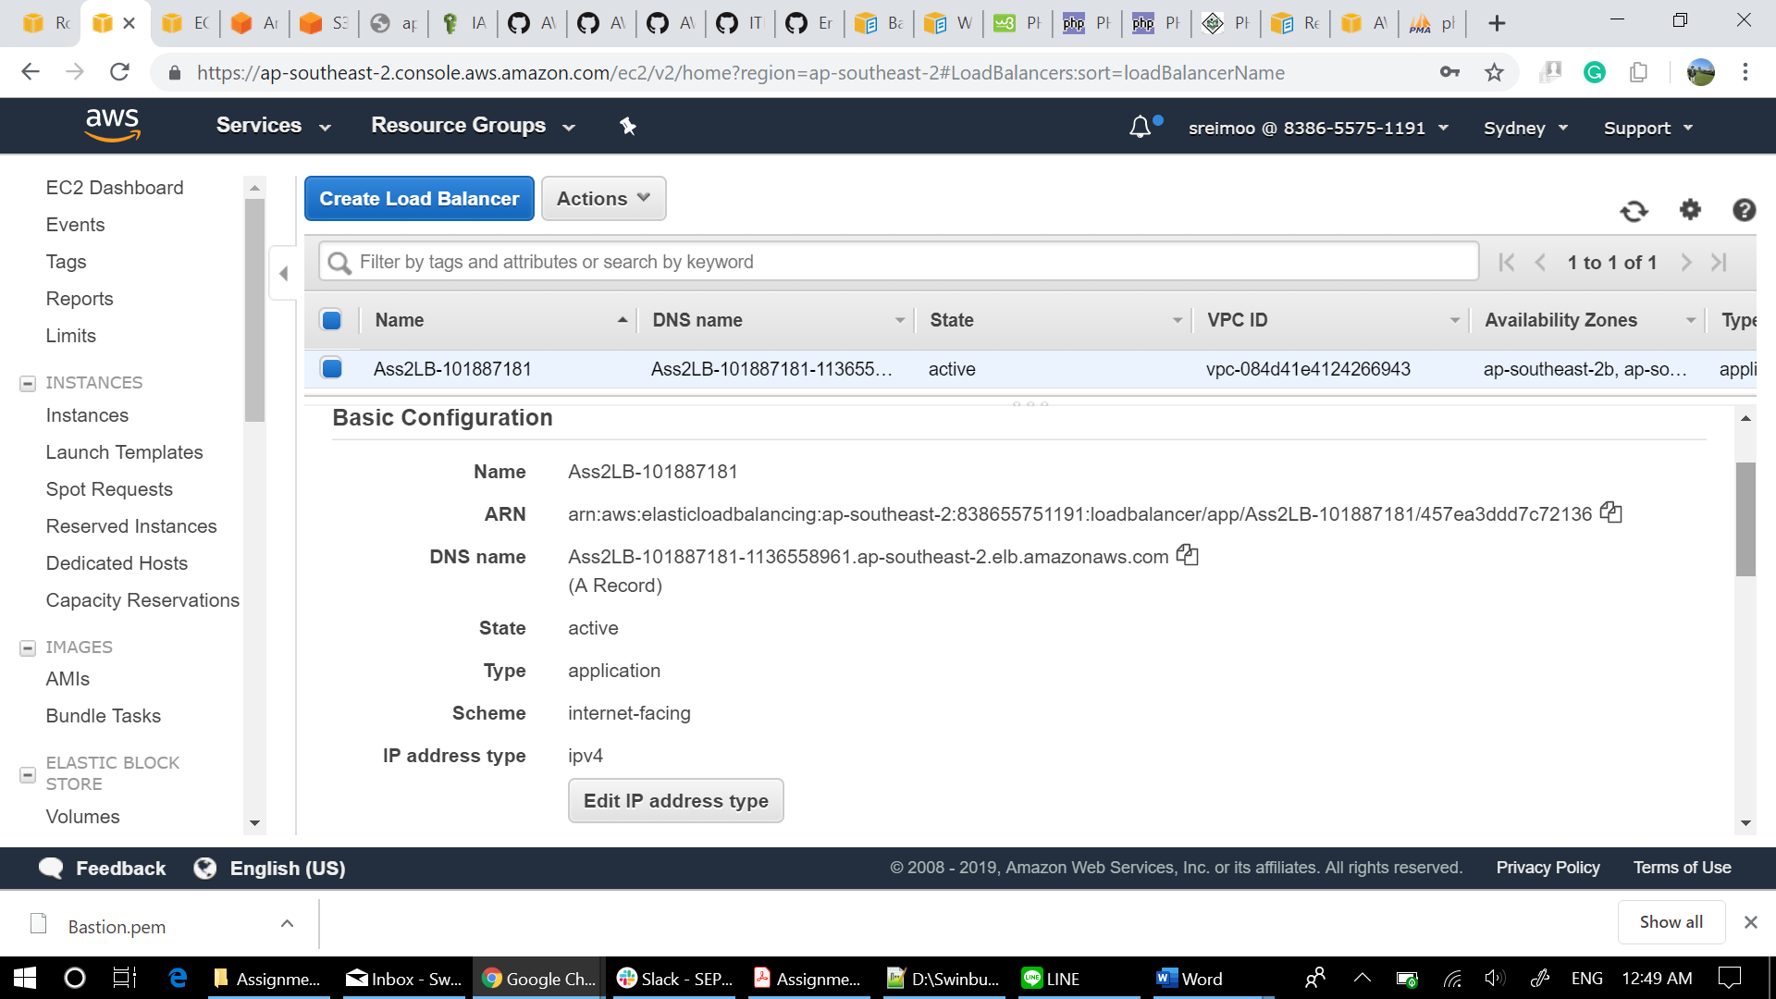

## Lb2

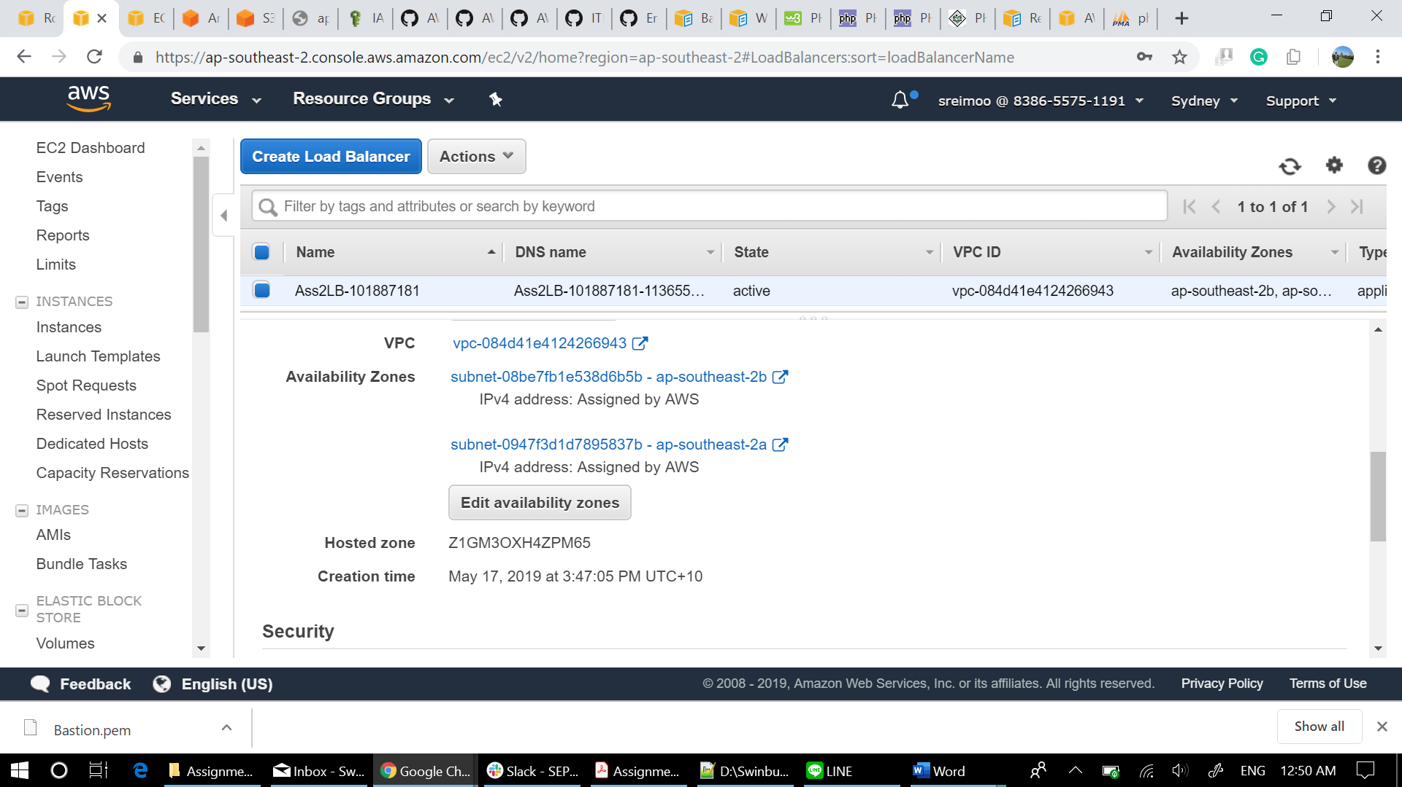

## Lb config 3

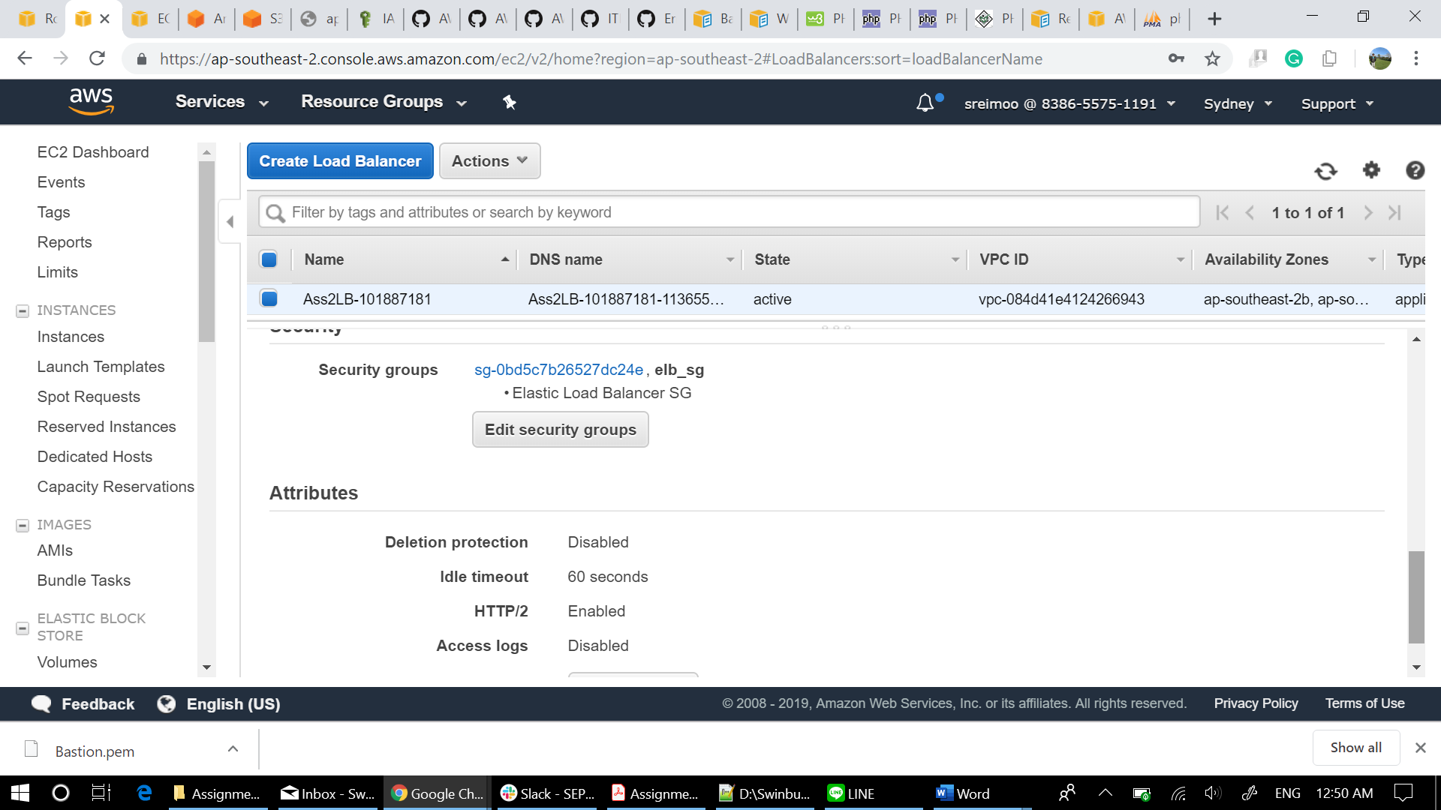

## Lb Listener

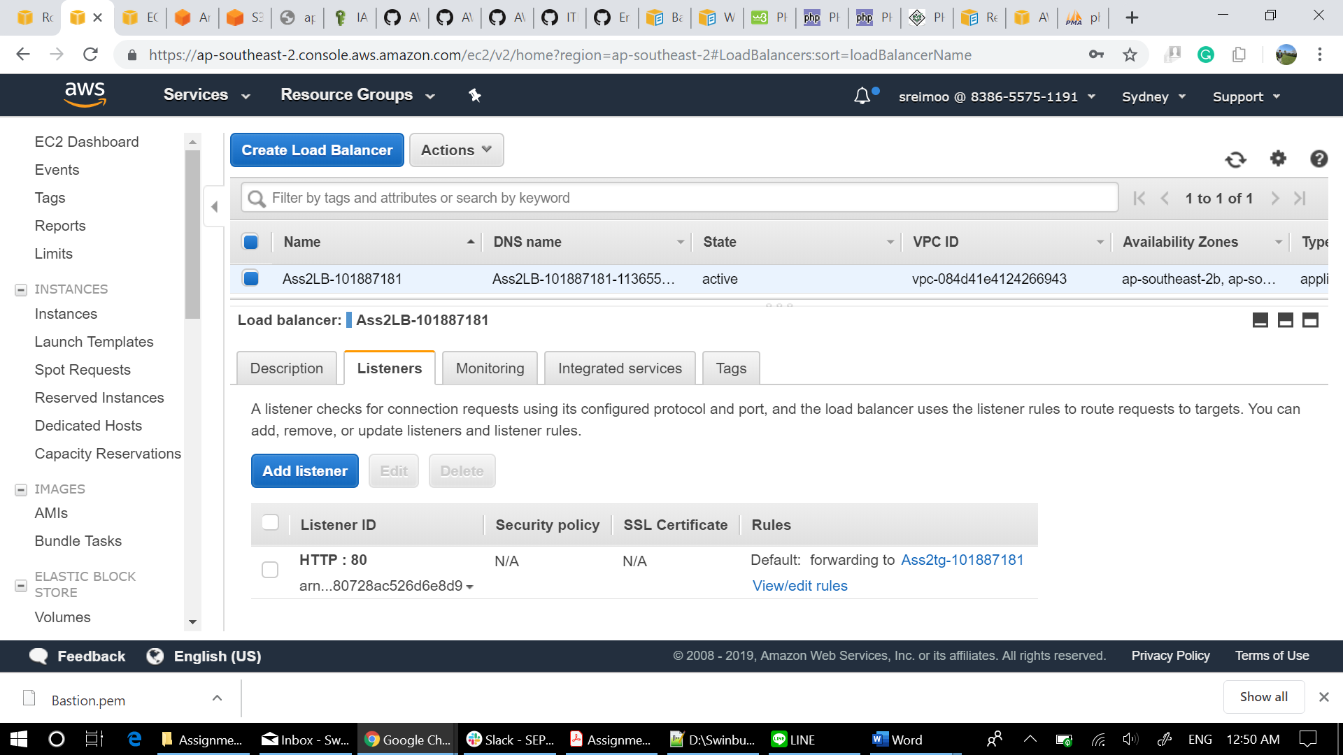

## Lb Tags

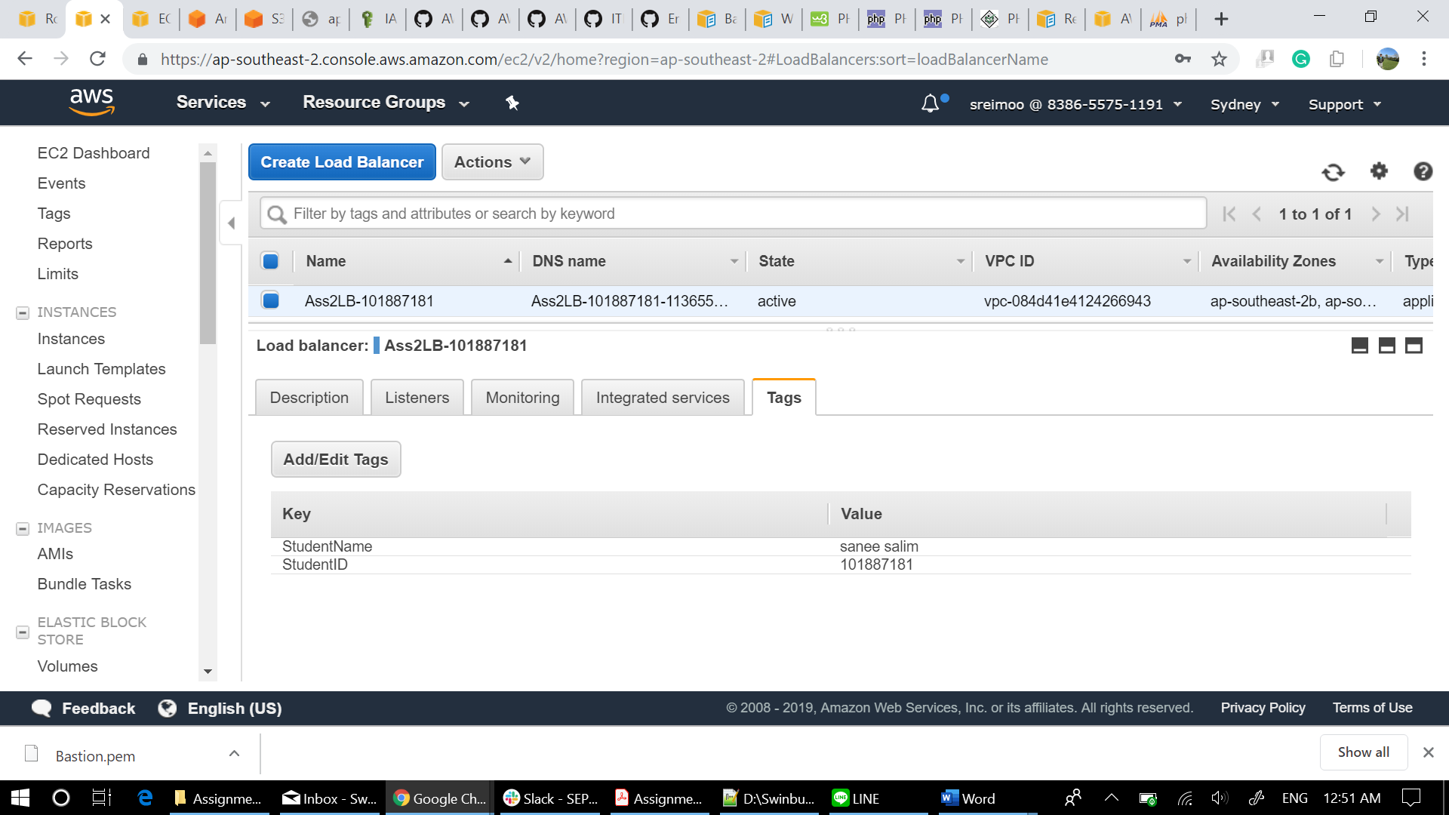

# Launch Configuration Details

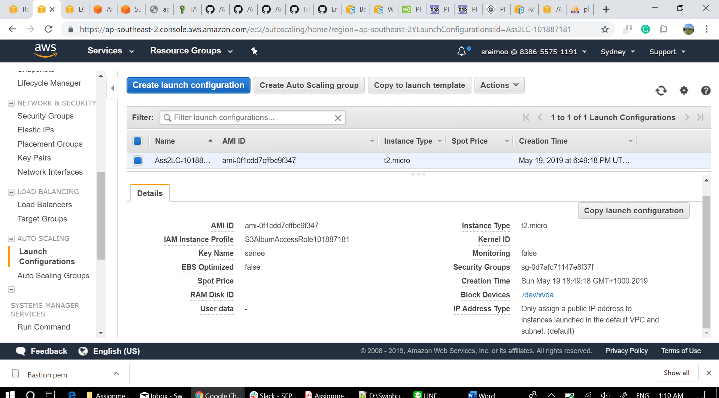

# Auto scaling group

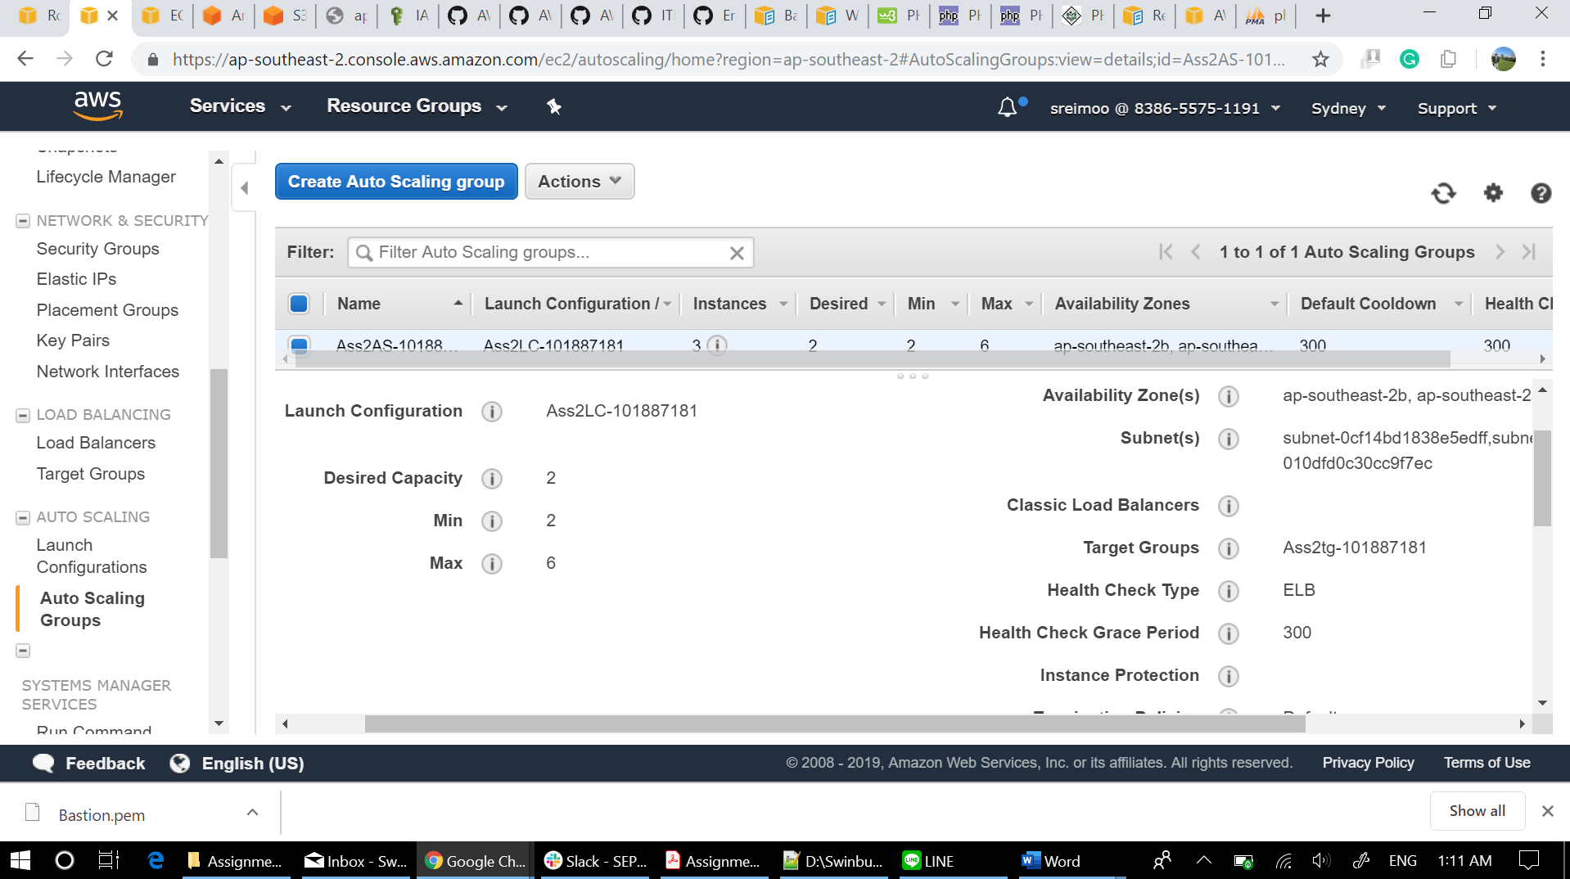

## Scaling Policy Decrease

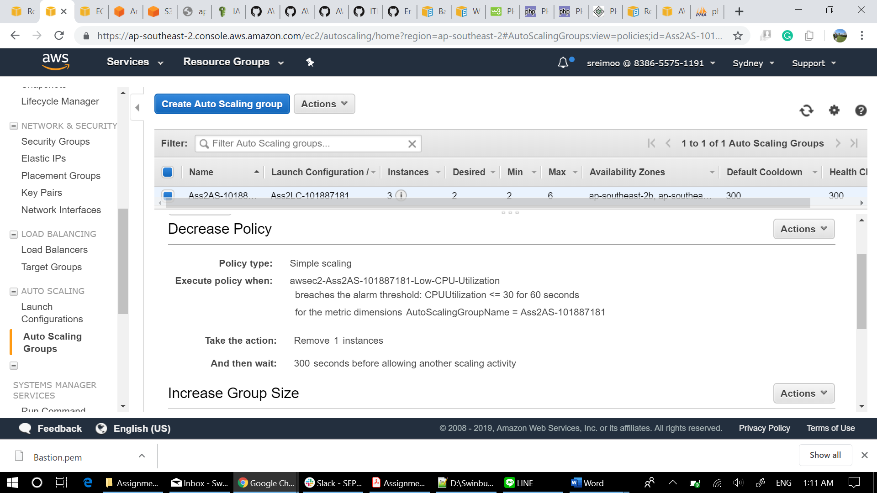

## Scaling Policy Increase

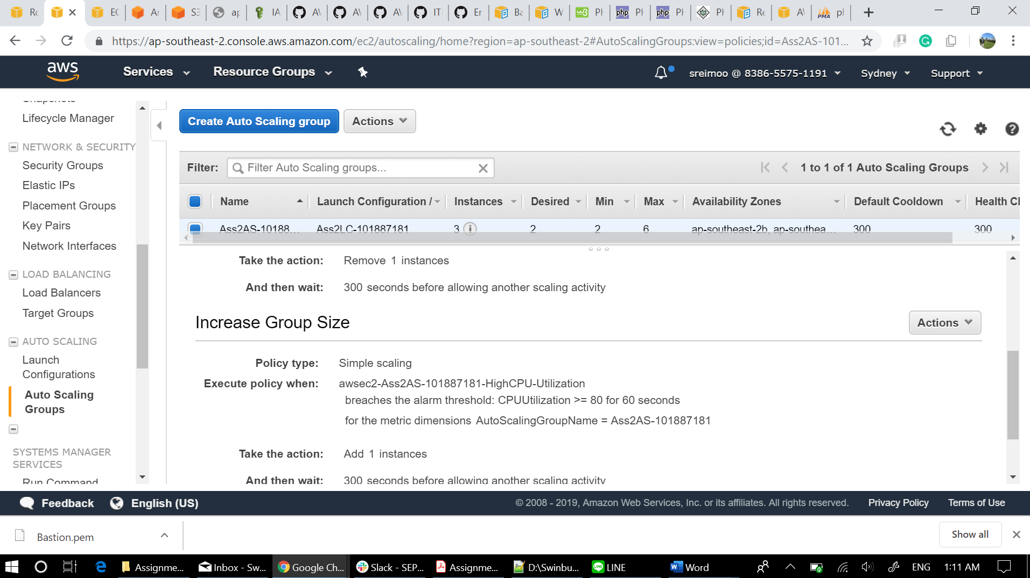

## Auto Scaling Tags

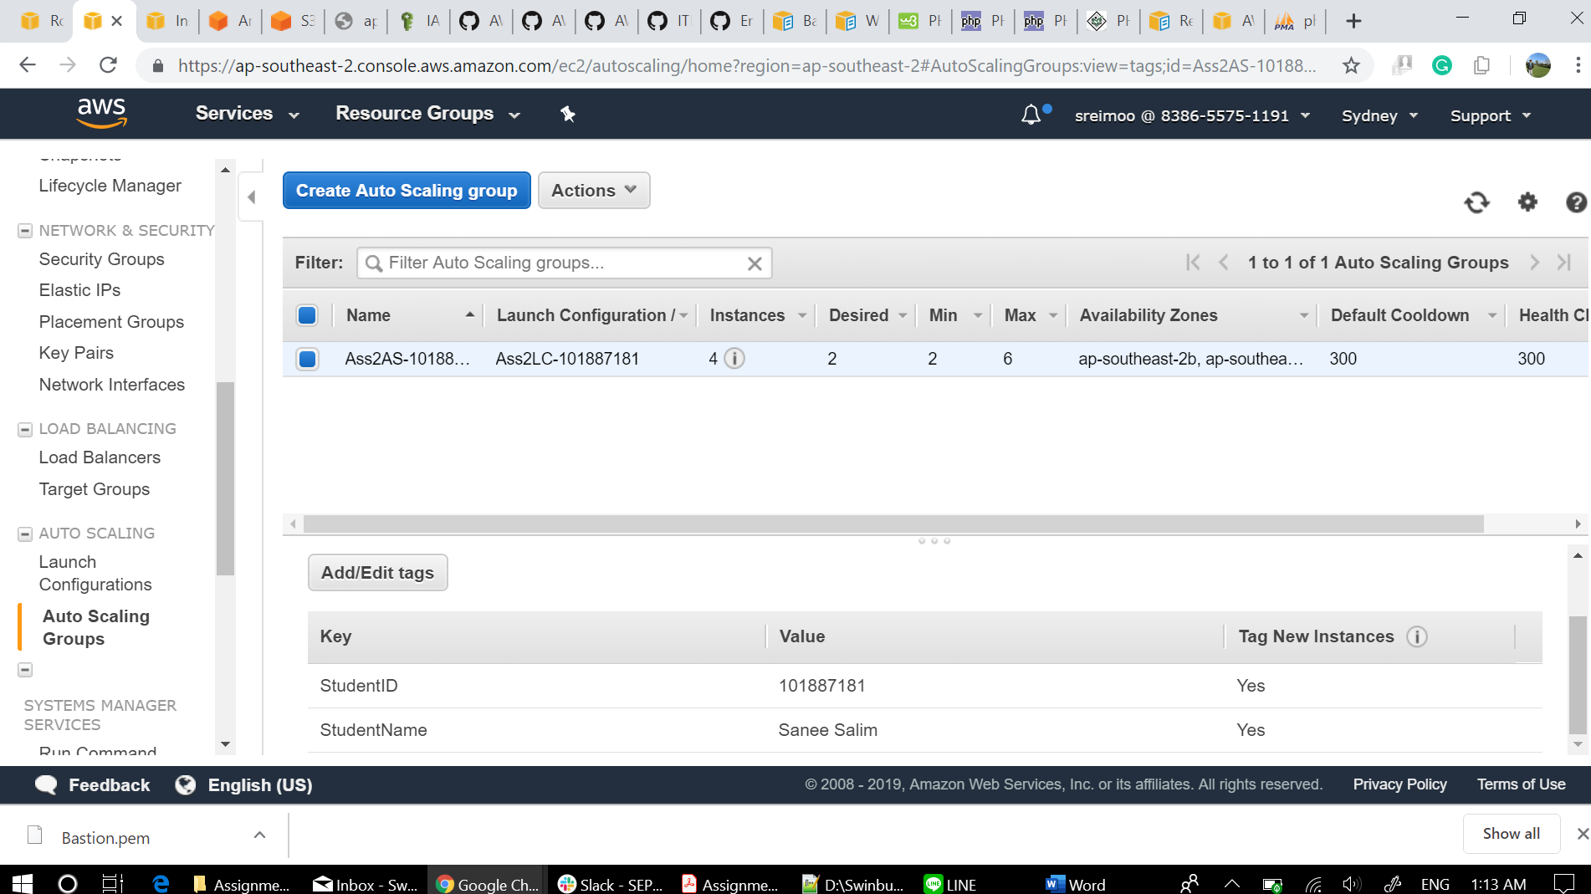

# S3Album Access Policy

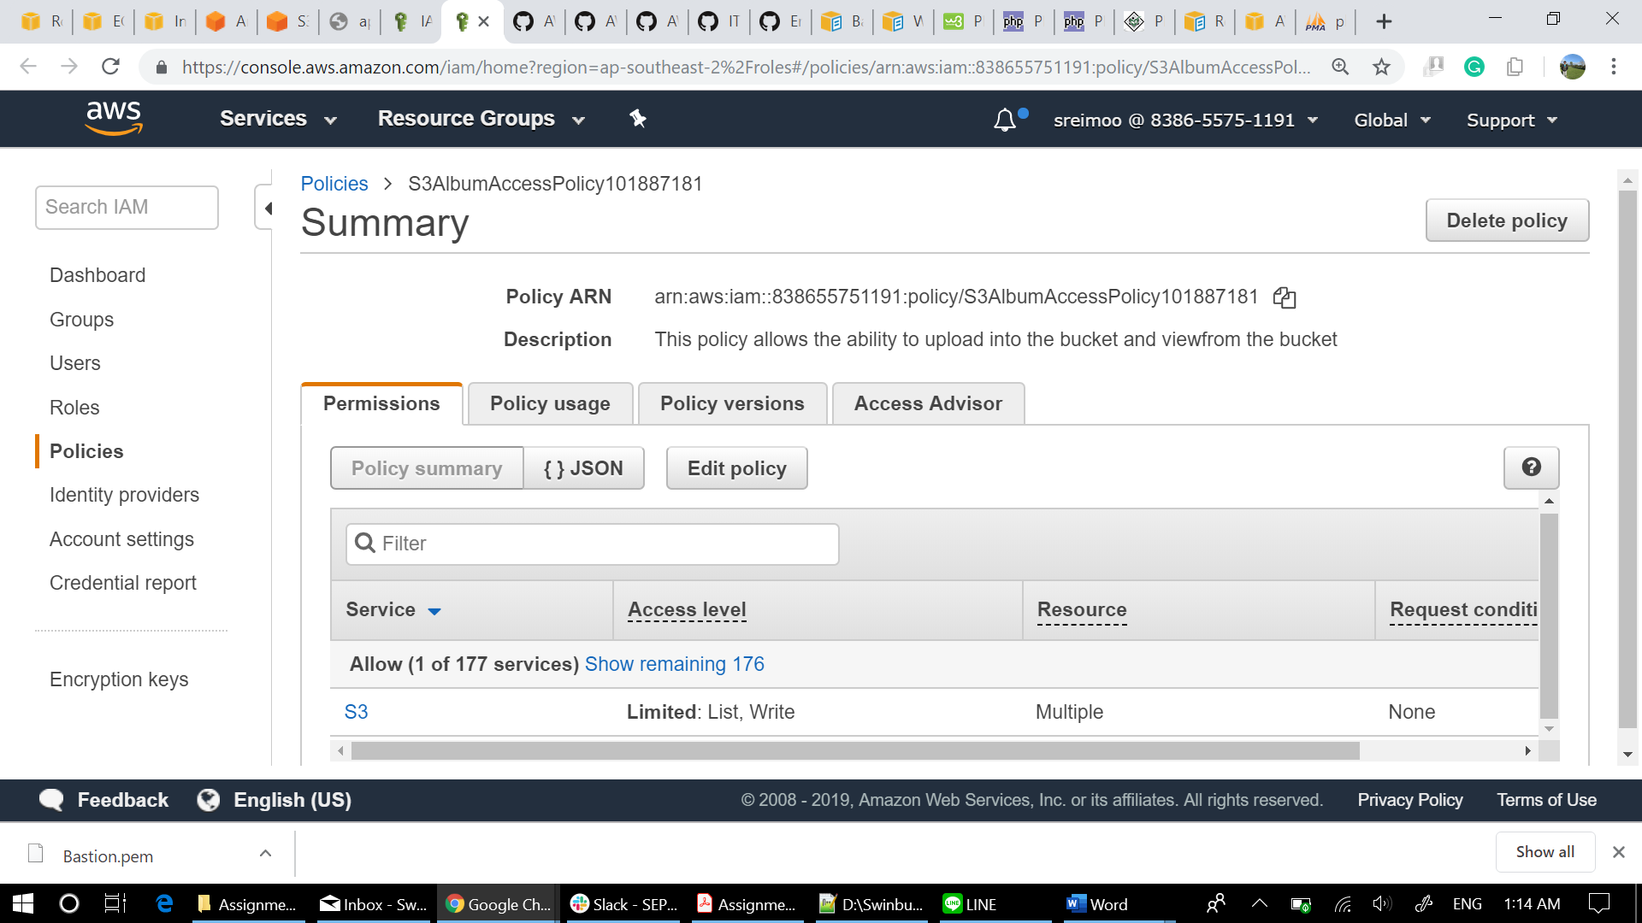

# Role

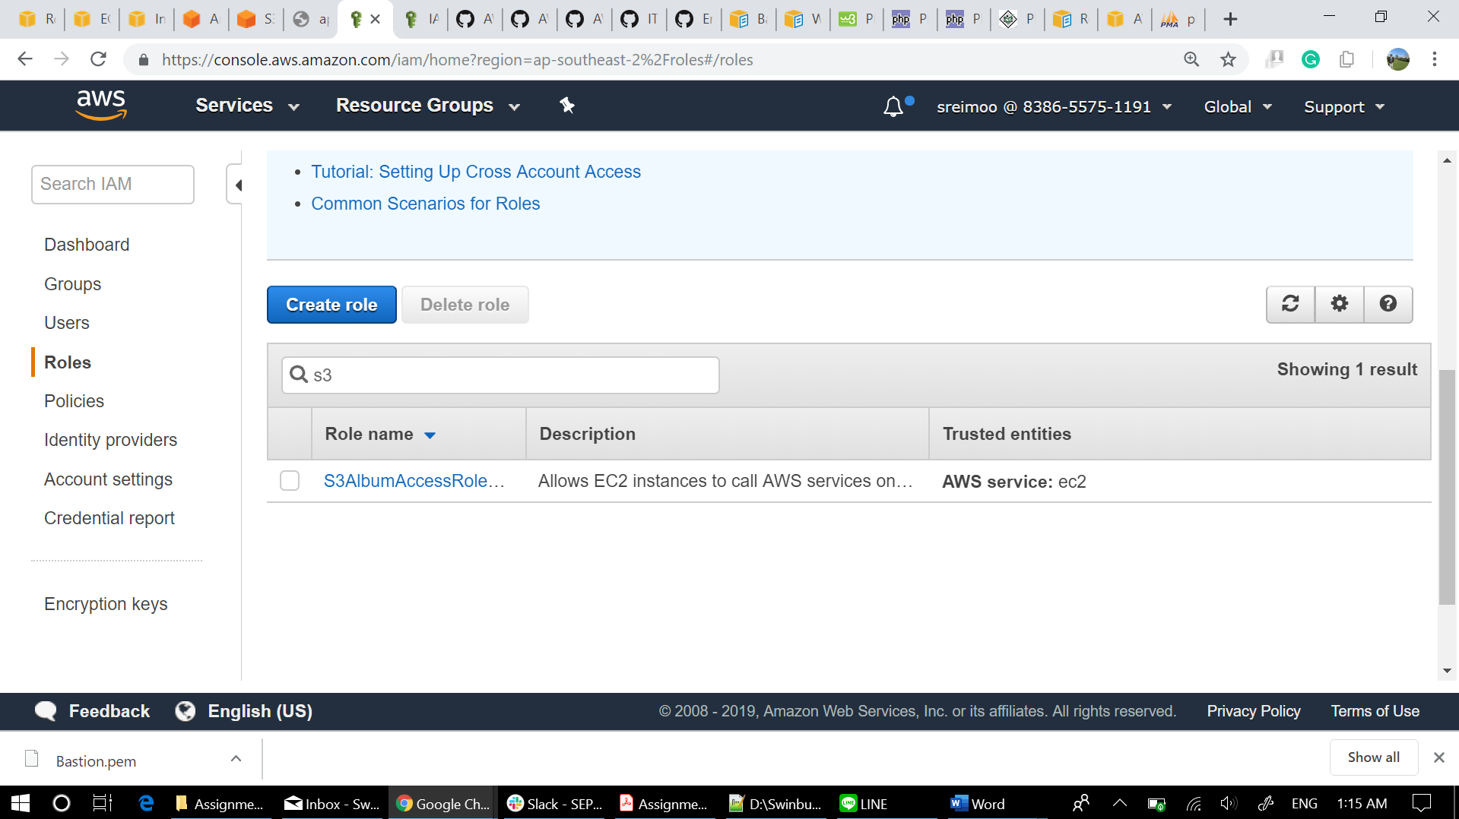

## Role Permission

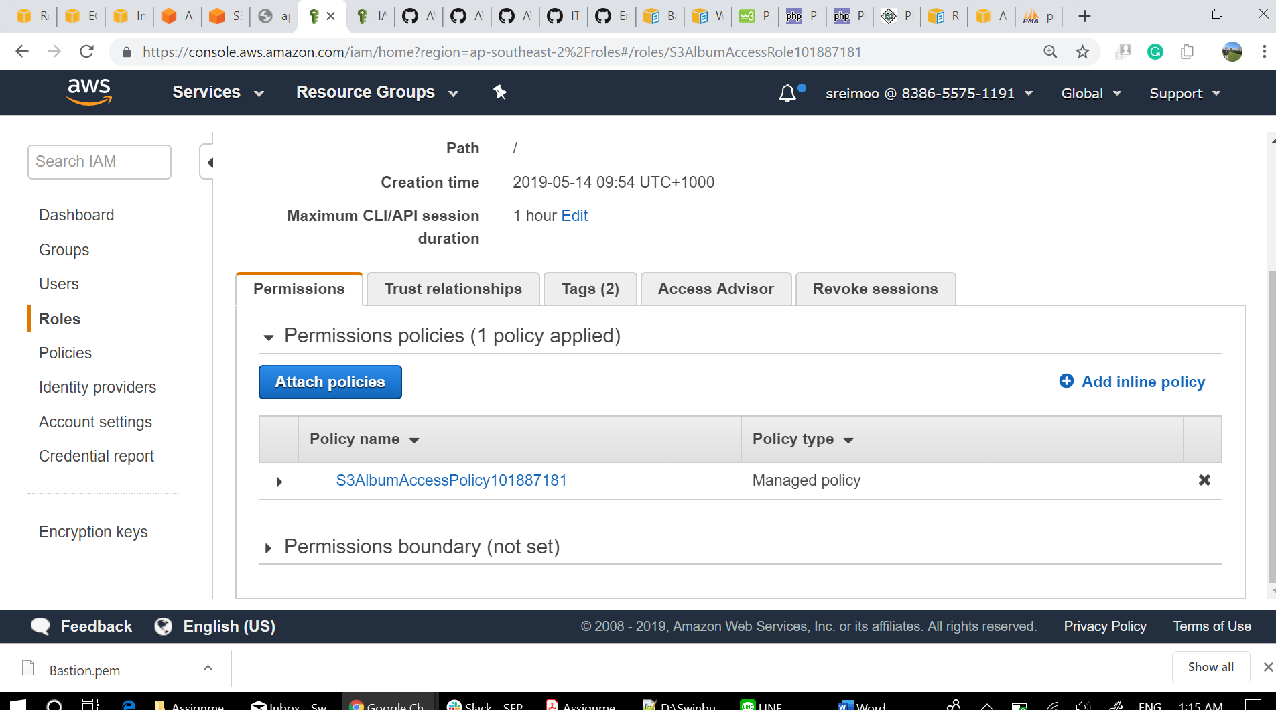

## Role Tags

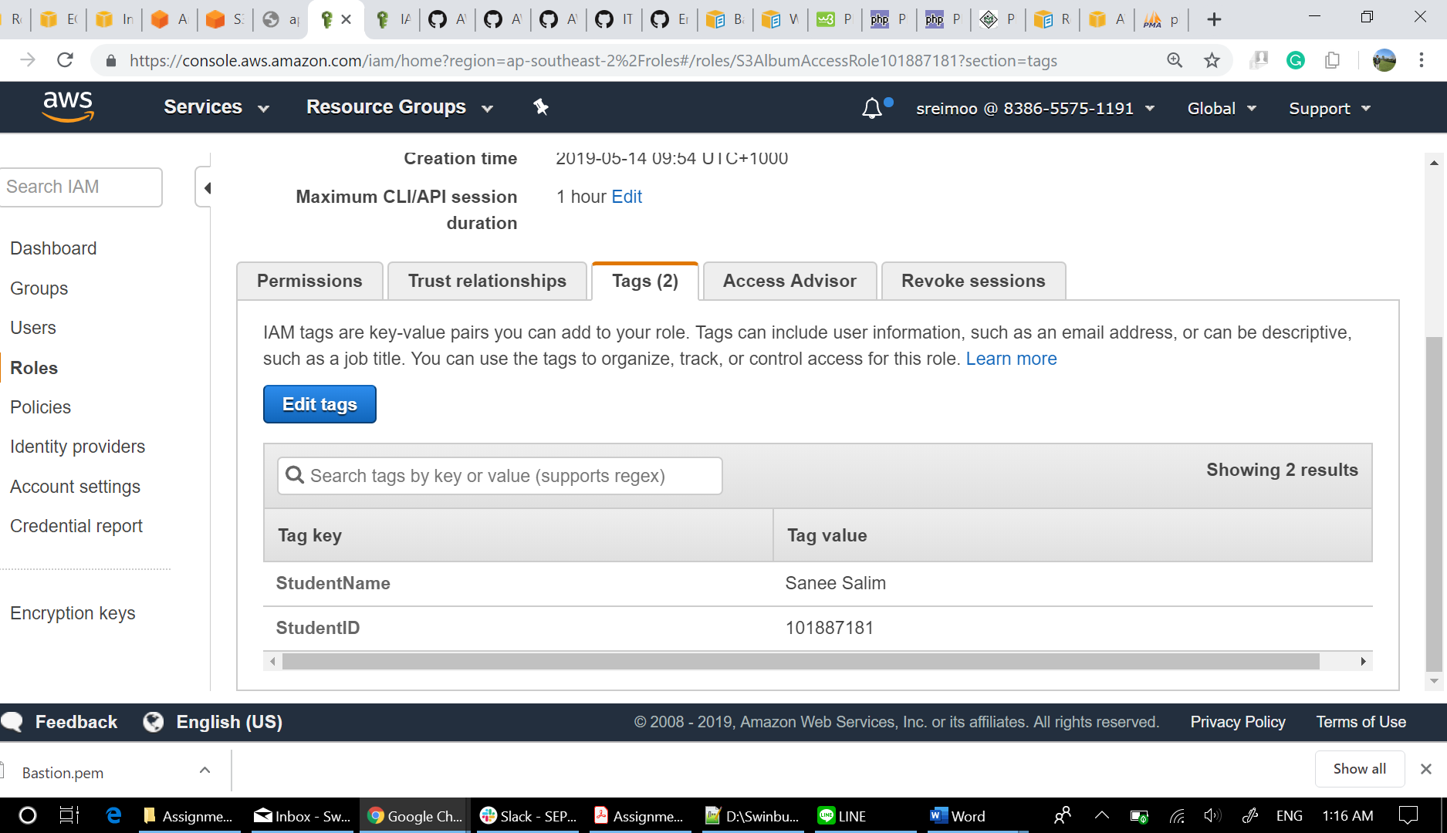

# S3 Bucket Policy

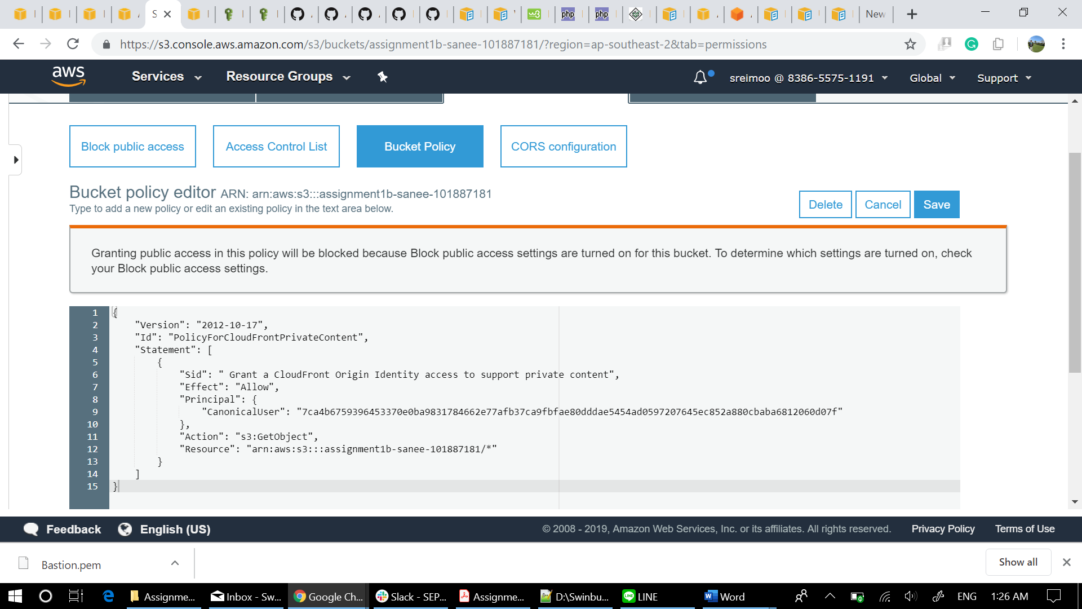

# Photo Viewer Page

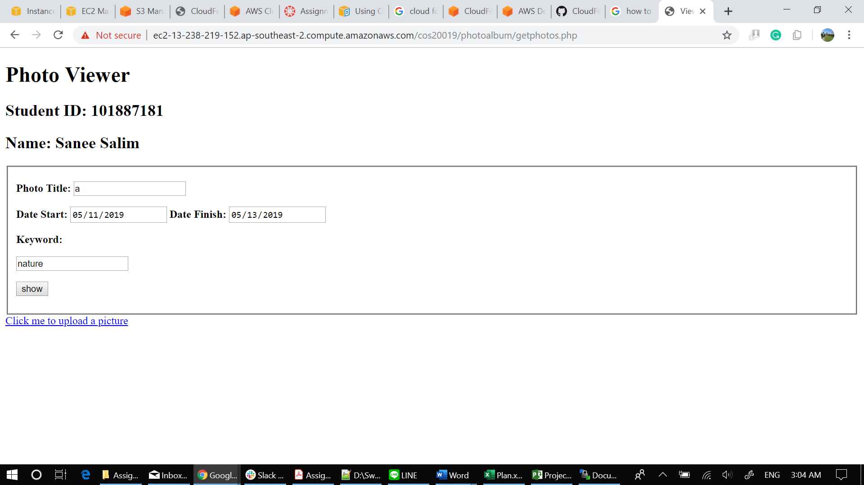

## Photo Viewer Result

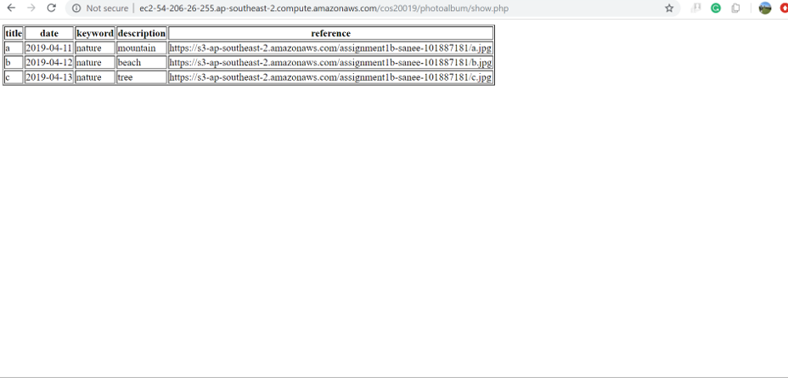

# Photo Uploader Page

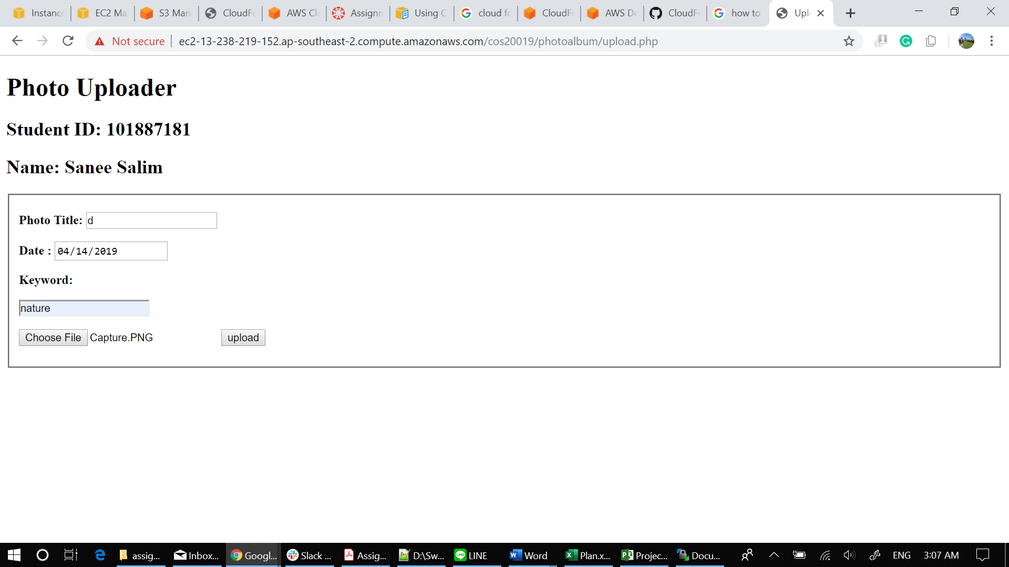

## Photo Upload Result (Success)

